St. Croix Writers and Wisconsin Writers Association

**Northland Fall Writers Conference**

September 28, 2019 8:30 AM – 4:00 PM

Solon Springs Community Center

**About This Conference:**

This conference is designed for you, writers *and* readers. During this exciting and eclectic day, you will explore and learn about several genres of writing, plus examine the benefits of professional editing for your manuscripts. This full-day conference includes opportunities for you to purchase books by regional authors in a vendor area. Conference fee includes your catered lunch, plus morning and afternoon refreshments.

**Location:**

Solon Springs Community Center, 11523 South Business Highway 53

Solon Springs, Wisconsin 54873

**Early Registration**: $49.00 ($39.00 for WWA members) includes conference, catered lunch, morning & afternoon refreshments. Artisanal coffee by Headwaters Roasting.

Early Registration deadline is September 17, 2019 for food count.

**Late Registration:** $55.00 ($45.00 for WWA members)

**Vendor Registration:** $64.00 ($54.00 for WWA members) includes six-foot covered table, conference, catered lunch, morning & afternoon refreshments.

***Special Note!* *All WWA Members receive $10.00 discount. Join today at WI.Write.org***

**Register at: www.WI.Write.org or mail with form below.**

**Lodging:**

***St. Croix Inn***, 11390 South 5th Street East, Solon Springs, WI 715-378-4444

***Swanson Motel and Campground***, 11829 S. Hwy 53, Solon Springs, WI 715-378-2215

***Airbnb, Inc.*** Available through search.

**Conference Agenda**

8:30 AM Registration and Check-in, Morning Refreshments. Vendor review & Book Sales

9:00 AM Welcome & Introductions: **Thomas Wayne King**, **WWA Board of Directors & author**

9:15 AM Keynote Address: **Brian Freeman, author**

**Thrill Seeker: A Writer’s Life in the Northland**

During his fifteen years as a Midwestern writer, **Brian Freeman** has seen the publishing world turn upside down and reinvent itself. But one thing hasn’t changed: the love that readers have for a great story. Brian will take you through the evolution of his career, from writing award-winning Northland thrillers to taking on Robert Ludlum’s Jason Bourne franchise. He’ll talk about the way he develops characters and stories for different settings, platforms, and audiences, and he’ll answer your questions about thriving in today’s publishing industry.

10:45 AM Vendor Area and Networking

11:15 AM Poetry Introduction: **Gary Banker, WWA Board of Directors and author**

11:25 AM Guest Speaker: **Karla Huston, Wisconsin Poet Laureate 2017-2018**

**Why Poetry Matters: Discussion and Reading**

  So what’s all the fuss about poultry? Those chickens work hard enough pluck-plucking

at the bugs in the lawn. We need more poultry, not less! Those brown speckled eggs,

those pretty red hens! Let’s hear it for—What? Oh, Poetry? Well that’s different! Never

mind! New Jersey poet William Carlos Williams said in his poem “Asphodel, That

Greeny Flower,” “It is difficult to get the news from poems yet men die miserably every

day for lack of what is found there.” If you are curious or in a state of denial about the

power of poultry, ‘er poetry, join former Wisconsin Poet Laureate Karla Huston to learn

why poetry still matters.

12:30 PM Catered Lunch (included in your conference fee). Vendor Area and Networking

1:30 PM Fiction Introduction**: Naomi Musch, author**

1:40 PM **Guest Speaker: Abby Frucht, author**

**The Tarot of Character**  
  
In this session, Abby will examine the reading of tarot cards as a method in the development of character and story in fiction and nonfiction.  She's no fortune teller (sorry!), but her discussion will feature the arc of the cards and a look at the intersection of will and fate that accompanies any tarot reading, as well as any making of narrative. She'll also look at the tarot of *place* and the tarot of *objects*.  Bring your favorite writing gear and a photo (or just a picture you keep in your mind is fine, too) of a person, place, or object that is important to you, for use in a simple, no-pressure writing exercise.

2:30 PM Afternoon Refreshment Break. Vendor Area and Networking

2:50 PM Editing Introduction**: Marty Russo, author**

3:00 PM **Guest Speaker: Barry Wightman, WWA President, Author, Editor**

**Is Your Manuscript Ready for Prime Time? What Editors Do.**

This session gets right to the heart of the matter: What makes a piece of writing publishable, ready to submit to literary agents or publishers? A fast-paced session sparked with real-world examples, this workshop covers what an editor actually does. Learn how he or she can help not only with basic *copy* editing (punctuation, grammar, etc.) but *developmental* editing - help with structure, arc, rhythm, characterization, continuity, all that stuff...and Hemingway's famous Theory of Omission. (What to leave in, what to leave out.) A good editor serves your story.

3:50 PM Closing Comments and Evaluations: **Thomas Wayne King**

4:00 PM Adjourn

**Special Thanks:**

Room at the Table Catering and Bakery

Solon Springs Community Center, Village of Solon Springs

St. Croix Writers

Wisconsin Writers Association

U-Roast-Em.com/Headwaters Roasting

**Featured Speaker: Brian Freeman**

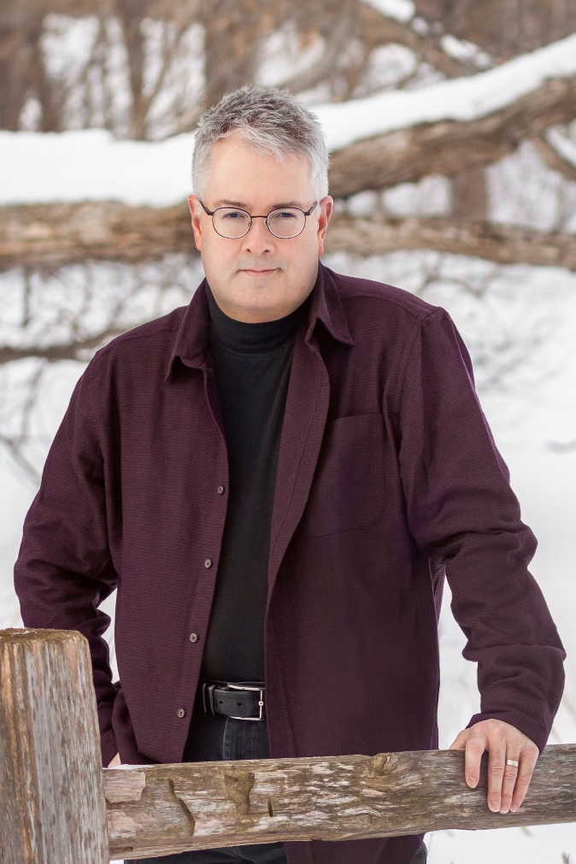

[JOIN BRIAN’S E-MAIL LIST](https://confirmsubscription.com/h/r/28C17E567DF1276D)

**GET TO KNOW BRIAN**

**#1 Amazon Bestselling Author**

Brian Freeman writes psychological thrillers that have been sold in 46 countries and 22 languages. His novel **SPILLED BLOOD** won the award for Best Hardcover Novel in the annual Thriller Awards, and his novel **THE BURYING PLACE** was a finalist for the same award. Other winners of this award have included authors Lisa Gardner, John Sandford, and Stephen King.

He has been named by Putnam and the Robert Ludlum estate as the official author to continue Ludlum’s famous Jason Bourne franchise. Brian’s new Bourne novel **THE BOURNE CONSPIRACY** will be released in 2020.

“My goal is to write books with haunting characters and a lightning-fast pace,” Brian says. “My stories are about the hidden intimate motives that draw people across some dark lines. The twists and turns keep you turning the pages, and each piece in the puzzle gives you new insight into the heroes, victims, and villains.”

“I don’t like books where the characters are all good or all bad,” he adds. “I want them to live in the real world, where morality means tough choices and a lot of shades of gray. I hope that’s why readers relate so intensely to the people in my books.”

Brian is particularly known for the “you are there” sense of place in his novels, from dead-of-winter Minnesota to the tropical storms of Florida. He scouts real-life locales for all of his books and brings to life dramatic settings such as Duluth, Minnesota, San Francisco, Tampa, Las Vegas, and Door County, Wisconsin.  “Nobody writes weather like Brian Freeman,” says one reviewer.

Brian has lived in Minnesota for more than 35 years with his wife, Marcia, who is his partner in life and in the book business.  They both stay closely connected to Brian’s readers.

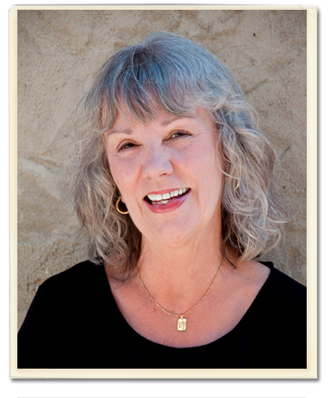

**Karla Huston**, Wisconsin Poet Laureate (2017-2018) is the author of *A Theory of Lipstick*(Main Street Rag: 2013) as well as 8 chapbooks of poetry including *Grief Bone,*(Five-Oaks Press: 2017). Her poems, reviews and interviews have been published widely, including the 2012 *Pushcart Best of the Small Presses* anthology. She teaches poetry writing at The Mill: A Place for Writers in Appleton, Wisconsin.

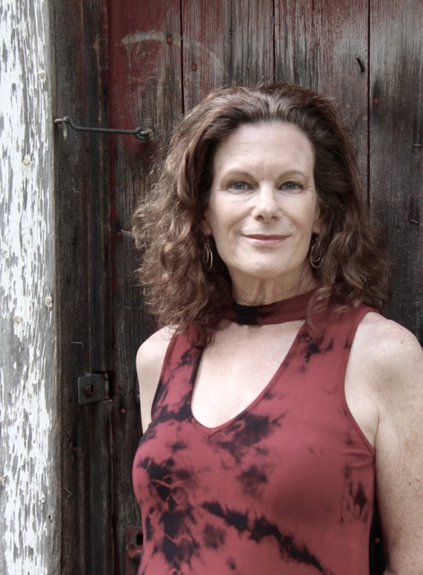

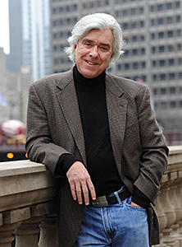

**Abby Frucht** is the author of two short story collections, Fruit of the Month, for which she received the Iowa Short Fiction Prize in 1987, and The Bell at the End of a Rope (Narrative Library, 2012). She has also written six novels: Snap; Licorice; Are You Mine?; Life before Death; Polly’s Ghost; and A Well-Made Bed (Red Hen Press, 2016), on which she collaborated with her friend and colleague Laurie Alberts. Abby has taught for more than twenty years at Vermont College of Fine Arts and has served as a judge for the Pen Faulkner award for Fiction. She lives in Oshkosh, Wisconsin. Photo by Heidi Hopkins.

**Barry Wightman** spent thirty years in the high tech industry, traveling the world. He earned an MFA from the [Vermont College of Fine Arts](https://vcfa.edu/) in 2010. He currently serves as creative director at [Forward Health Group, Inc.](http://forwardhealthgroup.com/) of Madison, WI.

Barry’s first novel, Pepperland, received a starred review on Booklist, and was a winner of the Silver IPPY from the Independent Publishers Association, 2014. Barry is past Fiction Editor (2011 – 2016) for [Hunger Mountain](http://www.hungermtn.org/), is President of the [Wisconsin Writers Association](https://wiwrite.org/), and is Program Chair for the [University of Wisconsin (Waukesha) Southeast Wisconsin Festival of Books](http://www.sewibookfest.com/). He is a talented voiceover professional and a Wisconsin Broadcasters Association award-winning essayist, whose work has been heard on [WUWM Milwaukee Public Radio](http://www.wuwm.com/programs/lake_effect/search_lake_effect.php?keys=barry+wightman).

He’s a long-time reviewer for the [Washington Independent Review of Books](http://www.washingtonindependentreviewofbooks.com/). His music and book reviews have also appeared in various publications in Chicago, Milwaukee and Washington D.C.

**Register Now at** [**www.WI.Write.org**](http://www.WI.Write.org) **or mail in your registration.**

**Registration Form**

**Name: ________________________________________________________**

**Address:_______________________________________________________**

**Email: _________________________Phone:_________________________**

**  Check    Purchase Order    Visa       MasterCard**

**Card # _____________Expires:_______ Signature:___________________**

** WWA Member (or Join by including your $35.00 membership fee)**

** $49 Early Registration   $39 Early WWA Registration (Before 9/19/2019)**

** $55 Late Registration     $45 Late WWA Registration**

** $64 Vendor Registration    $54 WWA Vendor Registration**

Register online, or complete and mail this form and include registration fee or purchase order payable to Wisconsin Writers Association:

Northland Fall Writers Conference

WI Writers Association and St. Croix Writers

% Debra King

P. O. Box 98

Solon Springs, WI 54873-0098